Architecture Design

# Excel Case Study

|  |  |
| --- | --- |
| **Written By** | Chanchal Gopalakrishnan |
| **Document Version** | 0.1 |
| **Last Revised Date** |  |

**DOCUMENT CONTROL**

## Change Record:

|  |  |  |  |
| --- | --- | --- | --- |
| **VERSION** | **DATE** | **AUTHOR** | **COMMENTS** |
|  |  |  |  |
|  |  |  |  |
|  |  |  |  |
|  |  |  |  |

**Reviews:**

|  |  |  |  |
| --- | --- | --- | --- |
| **VERSION** | **DATE** | **REVIEWER** | **COMMENTS** |
|  |  |  |  |

## Approval Status:

|  |  |  |  |  |  |
| --- | --- | --- | --- | --- | --- |
| **VERSION** | **REVIEW DATE** | **REVIEWED BY** |  | **APPROVED BY** | **COMMENTS** |
|  |  |  |  |  |  |

Contents

Excel Case Study 1

Change Record 2

1. Introduction 4
   1. What is Architecture design document? 4
   2. Scope 4
2. Architecture 5

ARCHITECTURE DESIGN 6

1. Excel Communication Flow 7

# Introduction

## What is Architecture design document?

Any software needs the architectural design to represents the design of software. IEEE defines architectural design as “the process of defining a collection of hardware and software components and their interfaces to establish the framework for the development of a computer system.” The software that is built for computer-based systems can exhibit one of these many architectures.

Each style will describe a system category that consists of :

* A set of components (eg: a database, computational modules) that will perform a function required by the system.
* The set of connectors will help in coordination, communication, and cooperation between the components.
* Conditions that how components can be integrated to form the system.
* Semantic models that help the designer to understand the overall properties of the system.

## Scope

Architecture Design Document (ADD) is an architecture design process that follows a step-by-step refinement process. The process can be used for designing data structures, required software architecture, source code and ultimately, performance algorithms. Overall, the design principles may be defined during requirement analysis and then refined during architectural design work.

# Architecture

### ARCHITECTURE DESIGN

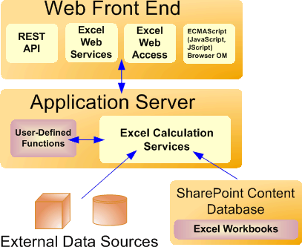

#### Gateway/Load Balancer:

In multiple-server configurations, Excel Services load-balances requests across multiple Excel Calculation Services occurrences in a farm configuration. If your installation includes multiple application servers, Excel Services will balance the load in an attempt to help ensure that no single application server is overloaded by requests.

Administrators can configure the load-balancing behaviour.

#### Web Front-End Servers and Back-End Application Servers:

The Excel Web Access, Excel Web Services, UDFs, JavaScript, the REST service, and Excel Calculation Services components can be divided into components on the Web front-end server and components that live on a back-end application server. The Web front end includes Excel Web Access, JavaScript, the REST service, and Excel Web Services. The Excel Calculation Services component resides on the back-end application server, alongside any UDF assemblies that an administrator has added.

#### Excel Calculation Services:

The role of Excel Calculation Services is to load workbooks, calculate workbooks, call

custom code (UDFs), and refresh external data. It also maintains the session state for interactivity. Excel Calculation Services maintains a session for the duration of interactions with the same workbook by a user or caller. A session is closed when the caller explicitly closes it or when the session times out on the server. Excel Services caches the opened Excel workbooks, calculation states, and external data query results, for improved performance when multiple users access the same set of workbooks.



#### Excel Web Services:

Excel Web Services is the Excel Services component that provides programmatic access to its Web service. You can develop applications that call Excel Web Services to calculate, set, and extract values from workbooks, and to refresh external data connections. By using Excel Web Services, you can incorporate server-side workbook logic into an application, automate the updating of Excel workbooks, and create application-specific user interfaces around server-side Excel calculation.

## Excel Communication Flow

